**Exhaustive Analysis of Indian Agriculture Sector Using Power BI**

Week 1 Report

By

Yogesh Saini, [yogesh720.ys@gmail.com](mailto:yogesh720.ys@gmail.com)

**ETL Method**

There are several methods that are used in power BI, one of them is ETL.  
ETL stands for (Extract, Transform, Load):

1. **Extract** : It is used to pull data from data sources like excel, csv, text, database files etc.
2. **Transform** : It is used for data processing and data cleaning such as handling errors and missing values.
3. **Load** : It is used for further analysis for keeping facts and insights via dashboard.

**Downloading and Installing Power BI**

**Step 1** : Download the Power BI Desktop from the official website <https://www.microsoft.com/en-us/download/details.aspx?id=58494>

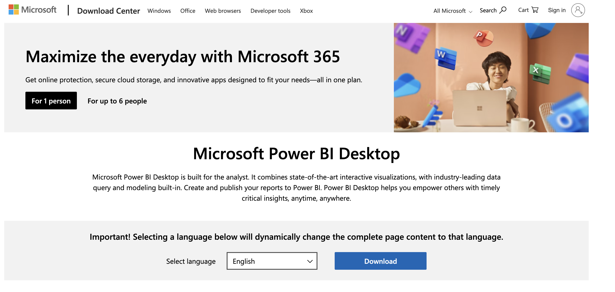

**Step 2** : Select the appropriate version.

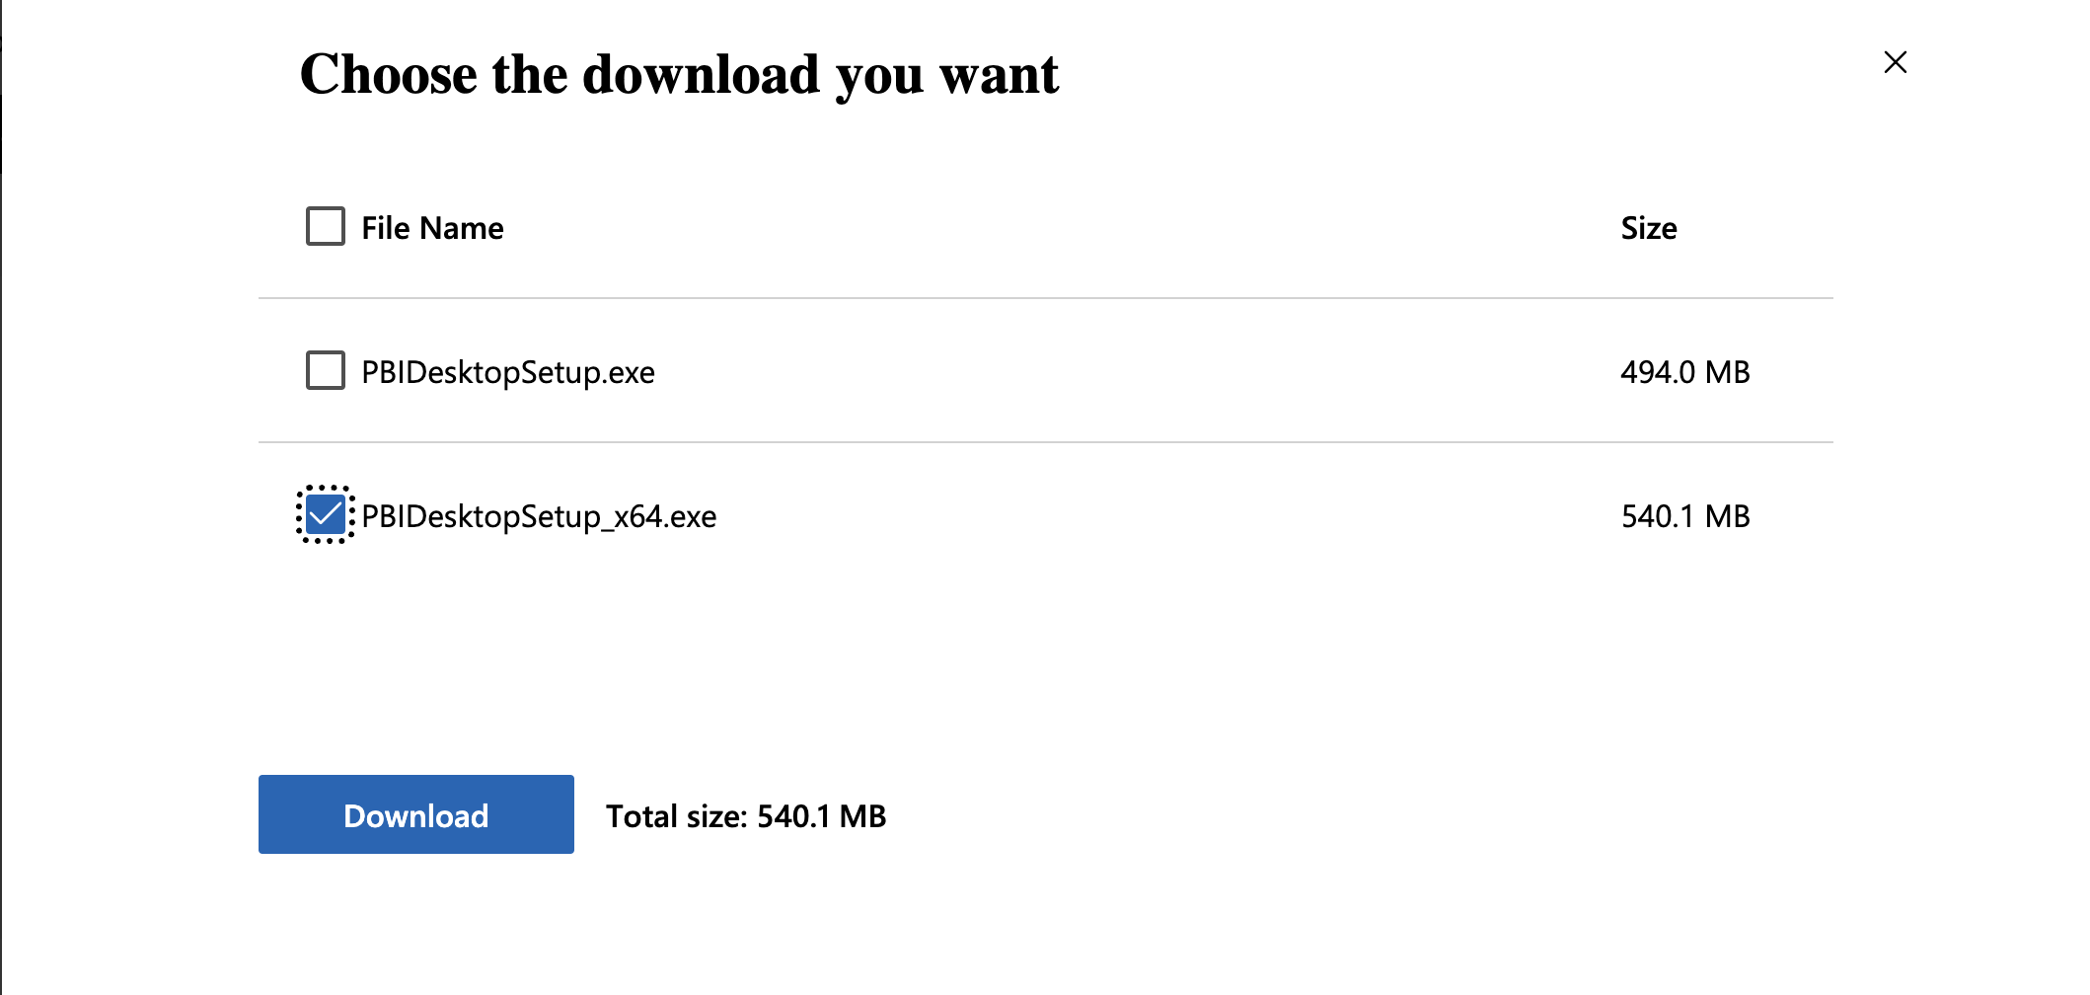

**Step 3** : Install the Power BI Desktop.

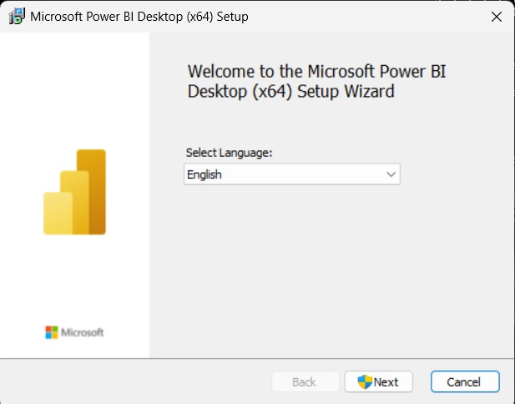

**Step 4 :** Accept the license agreement and click next.

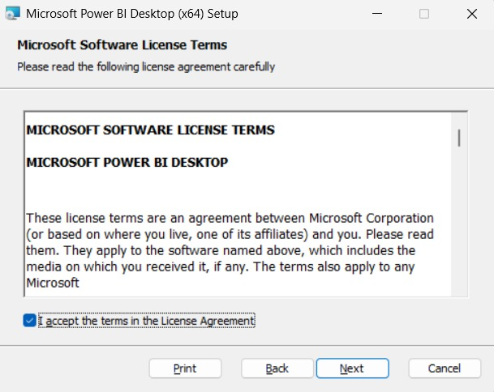

**Step 5 :** Select the installation location and click next then finish.

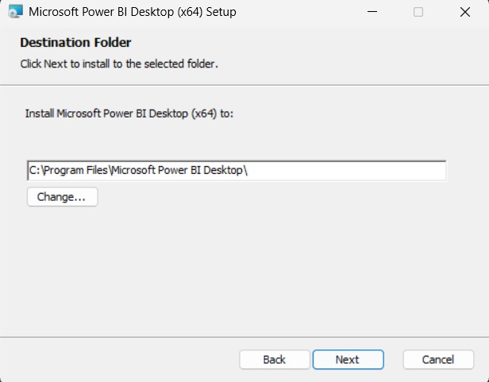

**Getting Started the Power BI**

1. Open the power BI desktop application.

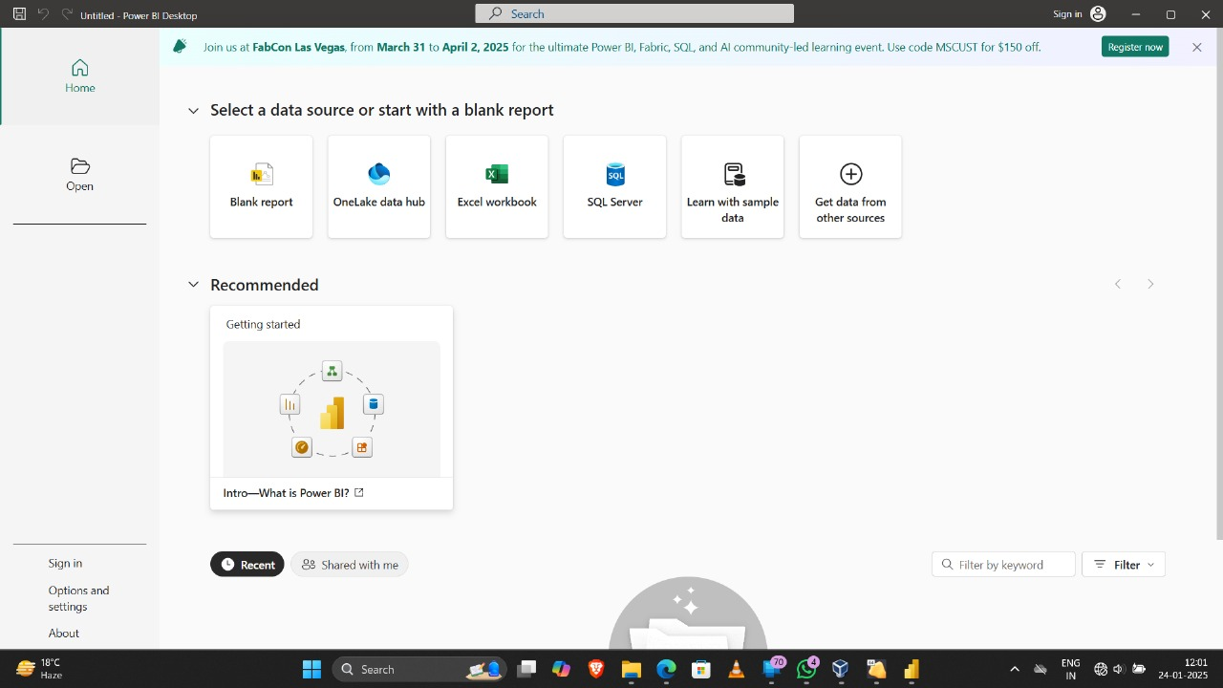

1. Click on the **Blank report** to make a new Power BI file. A new canvas will open. Now to Extract the data, select **get data from the home tab** according to the dataset file type.

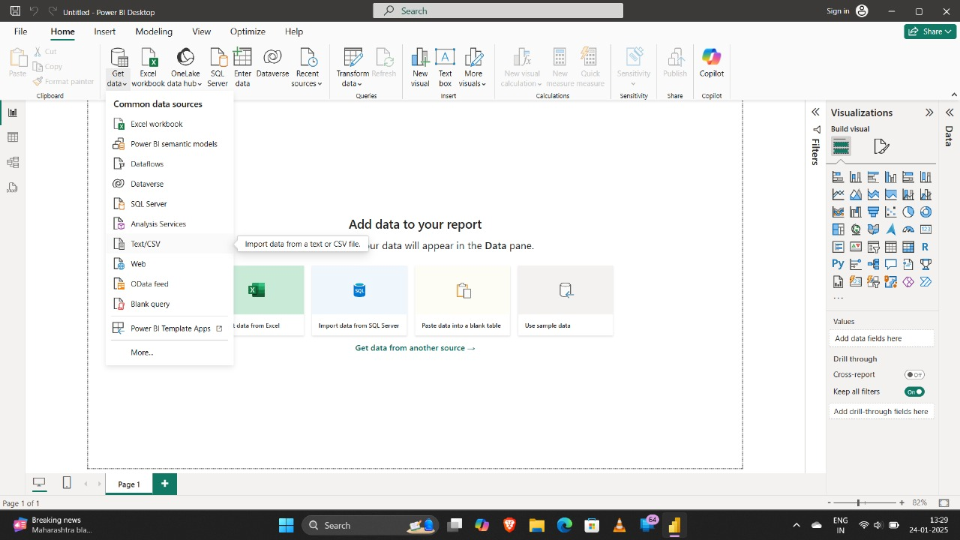

1. After selecting the dataset file a dialogue box will open, which have 3 buttons on the bottom (Load, Transform, Cancel). Click on the **load** button for now.

Load is when you have the cleaned data

Transform is used to clean the data.

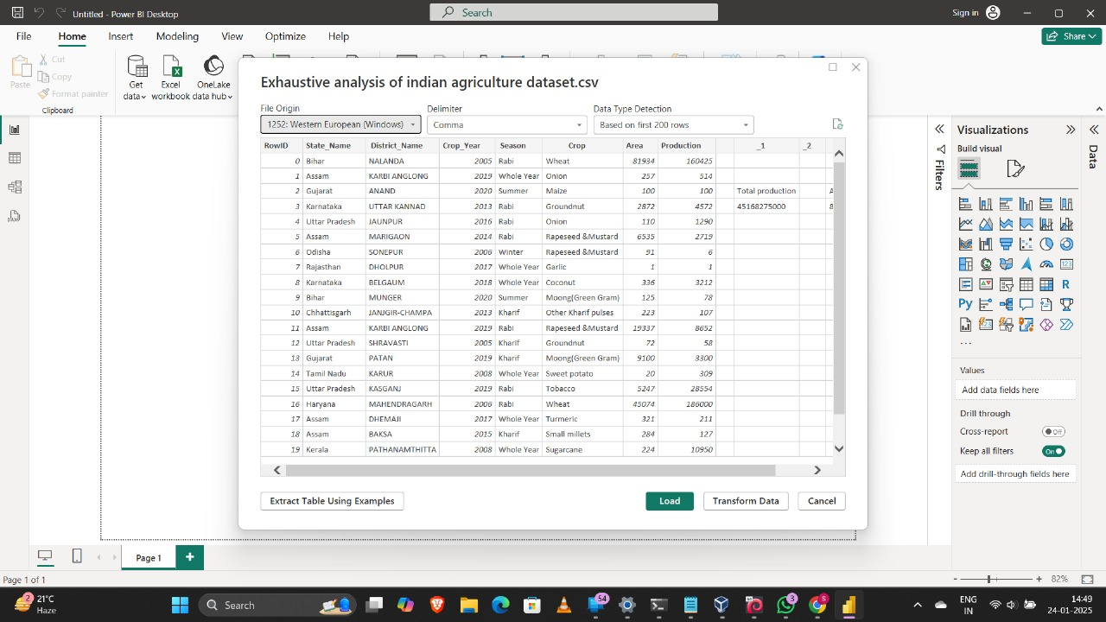

1. After loading we can see 3 different views on the left panel

**Report view** : This view is used for the visualisation.

**Table view**: This view is used to see the dataset in table form.

**Model view**: This view is used to see the relationships between the data.

This is the uncleaned table view of the dataset:

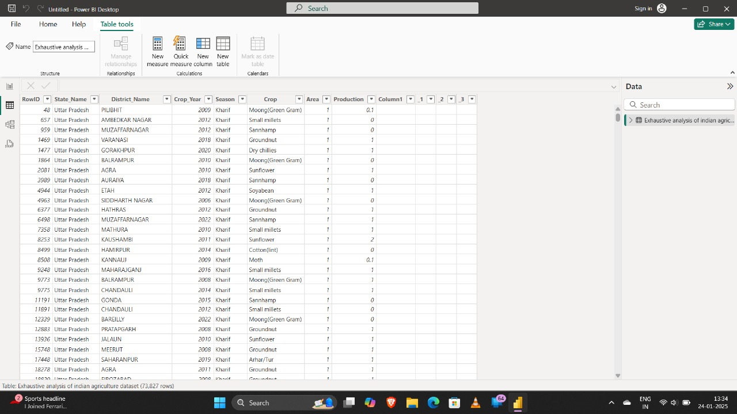

1. Now to transform the data click on the **transform data option in the home tab**. A new window will open named as **power querry editor**.

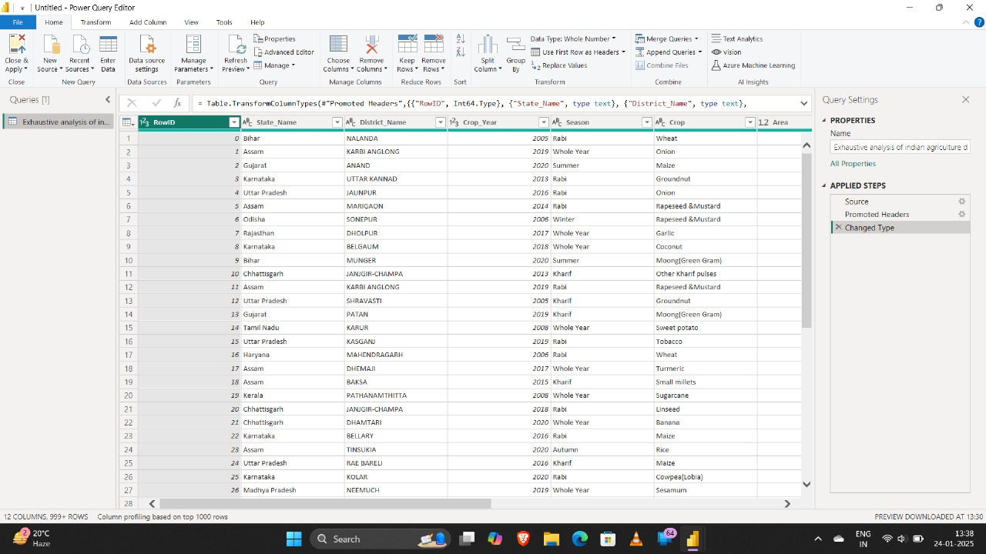

1. To delete unnecessary columns we can remove by just **right clicking on the column**. Delete all the empty and unnecessary columns.

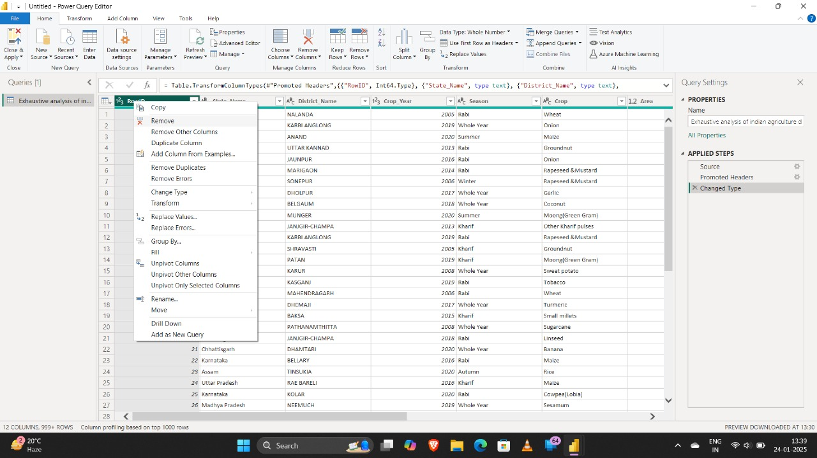

1. If we want to undo a deleted column we can click on the **cross sign** on the right panel.

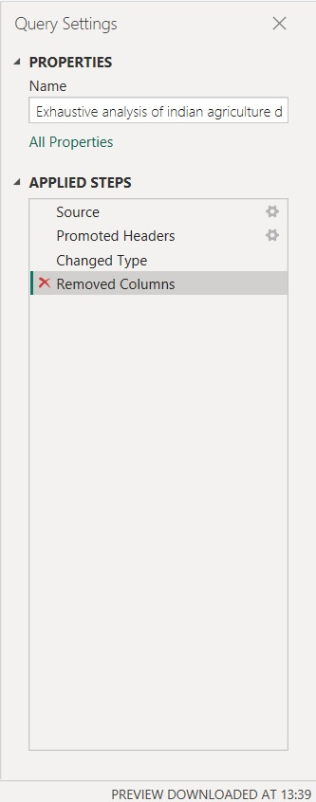

1. To check for any errors and missing values we can check the **Column quality option** in the view tab.

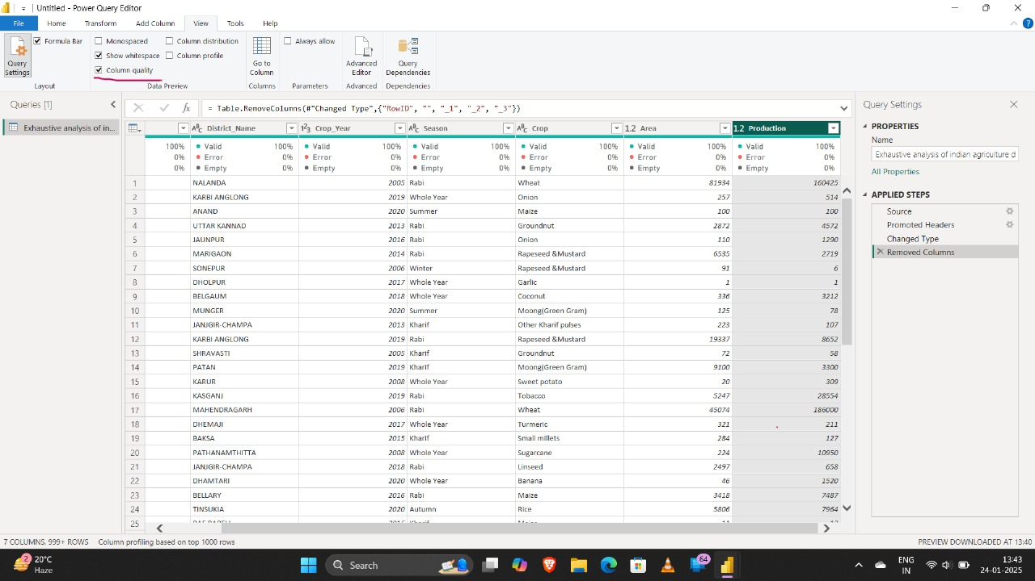

1. After cleaning all the data, we can click on **Close and Apply** option in the home tab.

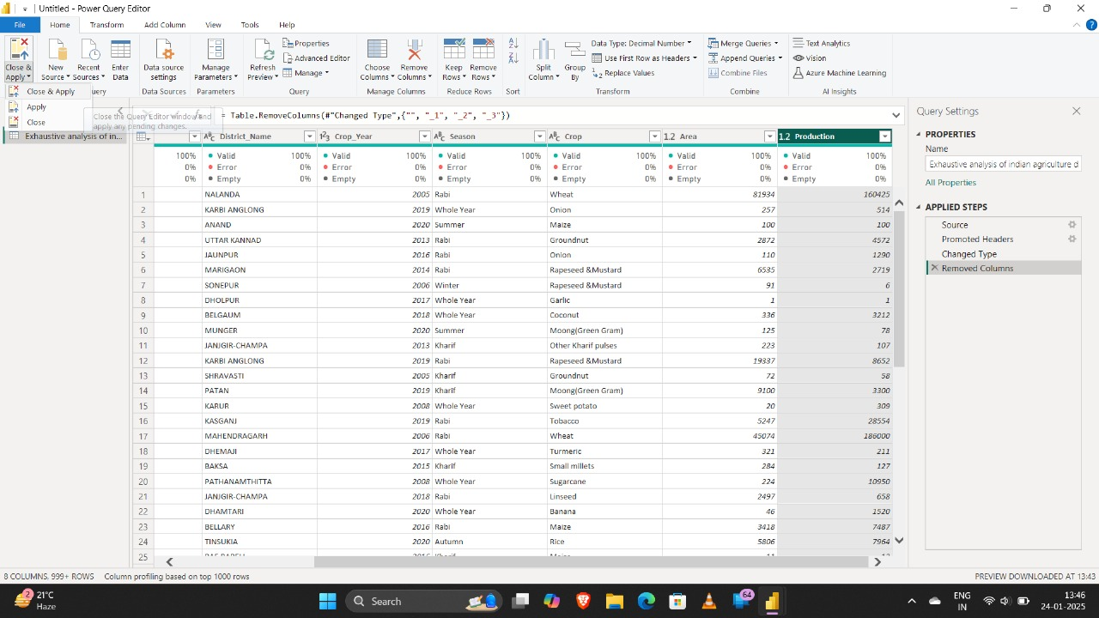

1. Now this is the Final **table view after cleaning the data.**

